**Project Report On**

E-Mart

**Submitted to**

**Information Technology Department**

**Year:- 2015-16**



**INFORMATION TECHNOLOGY DEPARTMENT**

**DR.S. & S.S.GHANDHY COLLEGE OFENGINERING & TECHNOLOGY SURAT**

**GUJARAT TECHNOLOGY UNIVERSITY**

**DR. S. & S. S. GHANDHY COLLEGE OF**

**ENGINERING & TECHNOLOGY**

**SURAT**



**PROJECT REPORT ON**

**E-mart**

**SUBMITED TO**

**INFORMATION TECHNOLOGY DEPARTMENT**

**YEAR:- 2015-16**

**GUIDED BY:- SUBMITED BY:**

Mrs. Suhani Chauhan Chotaliya Vaibhav (136120316041)

Hirpara Jaydip (136120316014)

Tarpara Dhruv (136120316061)

**DR.S.&S. S.GHANDHY COLLEGE OF ENGINERING & TECHNOLOGY**

**SURAT**

**CERTIFICATE**



**THIs IS TO CERTIFY THAT CHOTALIYA VAIBHAV, HIRPARA JAYDIP, TARPARA DHRUV HAVING ENROLLMENT NO.136120316011, 136120316014 & 136120316061 HAVE COMPLETED IDP PROJECT WORK HAVING TITLE “E-MART” THEY HAVE UNDER GONE THE PROCESS OF MANAGEMENT INDUSTRY DEFINE UNITS, LITERATURE SURVEY AND PROBLEM DEFINITION.**

**\**

**Index**

* **Project Profile**

**Chap-1: Abstract**

* **Modules**
* **Advantages**
* **Limitations**
* **Future Scope**

**Chap-2: Specification**

**Chap-3: Scope of Project**

* **Problem Identification**
* **Detail Summary**
* **Expected Output**

**Chap-4: Requirement Analysis**

* **Problem Solving Techniques**
* **Project Life Cycle Model**

**Chap-5: Organization Chart**

**Chap-6: Software Requirement Specification**

**Chap-7: E-R Diagram**

**Chap-8: DFD**

**Chap-9: Data Dictionary**

**Chap-10: Advantages & Limitations**

**Chap-11: Future Enhancement**

**Chap-12: Bibliography**

* **Project Profile**

**Project Name:** E-MART

**Type of Project:** PHP Website

**Project Description:** E-mart is a website which provides a medium to connect seller and buyers in the e-commerce industry.

**Team Size:** 3 member

**Front End:** PHP CSS3 HTML5

**Back End:** MYSQL

**Tools used:** XAMPP

ADOBE DREAMWEAVER 2015

E-Mart

**Definition**:-

E-mart

**Abstract**:-

* E-mart is a website which provides a medium to connect seller and buyers in the e-commerce industry. It reduce time, effort, and expense of consumer and on the other hand provides a platform for the seller.
* The objective of this project is to develop general purpose e-commerce store where any product can be brought from the comfort of home to the internet.
* For the entrepreneur, electronic shopping, generates new business opportunities means that there is a wider scope of consumer it makes comparative shopping possible.

**Modules:-**

1. Admin
2. Buyer
3. Seller
4. **Admin:-**

* Log In
* Manage Buyer
* Manage Seller
* Add / Remove Products

1. **Buyer:-**

* Register
* Log IN
* View Products
* Add to Cart
* Place Order

1. **Seller:-**

* Log In
* Sell Products
* Update Order Status

**Advantages:-**

* E-mart offers several advantages to consumer and companies including improvements of productivity, customer satisfaction and general overall productivity.
* E-mart provides a wider scope of consumer that can be attained by the entrepreneur.
* This will create an easier way for customer to buy items that the business is offering and also can view reviews of the product and customer service.
* Customer would now be able to view and get update on their favourite brands or products and special discount that apply and would be able to make purchase any time.
* Customer will have direct access to the product information, company, promotion and much more.

**Limitation:-**

* Geographical limitations.
* Product information must be update at arbitrary interval.
* Payment methods are limited.

**Future Scope:-**

* Widen the range of product sold.
* Provide more payment methods.
* Widen the geographical area.

**Specification**

**Front End:-**

* PHP (5.6.8)
* HTML5
* CSS3
* JavaScript

**Back End:-**

* MySQL 5.5.32

**Other Tools:-**

* XAMPP Software Package (3.2.1)
* Adobe Dreamweaver CC 2015

**PHP:-**

* PHP is a server scripting language and a powerful tool for making a dynamic and interactive web pages.
* PHP is widely used, free and efficient alternative to competitive such as Microsoft’s ASP.
* PHP is a free software (Open Source) related under PHP license.
* Founder of PHP is Rasmus Lardorf. PHP was written in the 7 programming language in 1994.
* Original meaning of PHP is Personal Home Page.
* Core PHP was rebuilt by Zeev Suraski and Andi Gutmans in 1997 and names “Hypertext Pre-processor”.

**MySQL:-**

* MySQL is open source relational database management system that relies on SOL for processing data in the database.
* MySQL falls under the GNU General Public License.
* MySQL is most commonly used for web application because of its speed and reliability.
* MySQL provides a very high performance and it is multi-thread and multi-user relational database management system.
* MySQL is very lightweight application and support indexing and binary object.

**XAMPP:-**

* XAMPP is a light-weight easy to install bundle that will allows us to do local development on website in case we don’t have server hosted.
* It is an open Source licensed product.
* XAMPP consist of three main things that we need to know is:
* Apache web Server
* PHP
* MySQL
* Hence, this three things are included in the XAMPP.

**CSS:-**

* A cascading Style sheet contains style rules that are applied to element in a webpage.
* CSS defines how HTML elements are to be displayed.
* CSS saves a lot of work and external style sheets are stored in CSS files.

**JavaScript:-**

* JavaScript is a programming language of HTML and the Web.
* JavaScript is a dynamic Programming language.
* It is most commonly used as part of web browser, whose implementation allow client-slide script to interact with user, control browser, communicate asynchronously, and alter the document, content that is displayed.
* JavaScript is multi-paradigm language, support OOP, imperative and functional programming Style.

**Scope of Project**

**Problem Identification:-**

* There is not many website such that all variety of products are available.
* When the courier guy comes the buyer may or may be not at home.
* There is not such type of service like home delivery, COD for food products.
* Difficulty in buying & comparing products.
* Seller have a limited scope of geographical area.
* In a single local store, they don’t have all the variety of products.

**Expected Outcomes:-**

* Buyer will get the home Delivery and cash on delivery.
* Buyer will get the delivery at their preferred time.
* Buyer will get all the variety of products that they can’t get from a single local store.

**Detailed Summary of Project**

* The name of the website is E-mart which is made especially for purpose of buying grocery or any daily usable products in for prize.
* Many types of services is provided by E-mart like person will get description of all product but it is not necessary that visitors must have to buy things or products, they can also visit our website for getting information about products and compare them.
* Our website consist of main three modules.
  + Buyer
  + Seller
  + Admin
* First of all, buyer signup or goes into guest mode. In guest mode he/she can’t buy products, he/she only can view and get information about products.
* After signup, he/she Sign IN and then surf our website for desired products. He/she can also add products into wish list or cart and also place order and select time for delivery and simply logout.
* Seller is the person who will sell or deliver the products according to order and time.
* Seller check the database and get information of order and deliver products to buyer.
* Admin manages the whole website and have a full access over the website.
* Admin can add and remove products change the price and info.
* Admin also can see the profile of buyer and seller and manage them.

**Requirement Analysis**

**Project Solving Techniques:-**

* Bottoms-up approach.
* It is the pricing together of system to give rise to grander, thus making the original system, sub-system of element system.
* In a bottom-up approach the individual base elements of system are first specified in great details.
* These elements are then linked together to form larger sub-system, which then in turn are linked, sometimes in many levels, until a complete top-level system is formed.
* Incremental model is a popular version of the system development life cycle model for software engineering.
* By this way, it is easy to make a grander system by small modules.

**Project life cycle model (Incremental):-**

* Project life cycle model is incremental model.
* Incremental model combines elements of the linear sequential model with the iterative philosophy of prototyping.
* In this, incremental model first increment is called core product.
* In core product basic requirement are added but some unknown supplementary features remain undelivered.
* This core product is used by customer to evaluate the system and next increment is planned to develop.
* During first requirement analysis phase, customer and developers specifies as many requirements as possible and prepare documentation.
* First version of product with minimal and essential feature is launched to market.
* Based on the feedback and experience with this version, list of additional features are added.
* This process is repeated following the delivery of each increment, until the complete product is produced.

**Advantages of Incremental Model:-**

* We can add feature/modules as per our need.
* Less cost and time is required to develop core product.
* It can result in better testing, because testing each increment is likely to be easier than testing entire system.
* Incremental funding is allowed, means only one or two increments might be funded when the program starts.

**Software Requirement Specifications**

|  |  |  |  |  |
| --- | --- | --- | --- | --- |
| Person | Main Activity | Database Activity | Activity | Document |
|  |  |  |  |  |
| Buyer | Sign-up | Create | Cart Table |  |
| Update | Buyer Database  Updated |  |
|  |
|  |  |  |  |
| Login | Create |  |  |
|  |  |  |  |
| Product add  To Cart | Update | Cart table  Updated |  |
|  |
|  |  |  |  |
| Place Order | Update | Cart table  Updated |  |
|  |
| Update | Current Order  Table Updated |  |
|  |
| Update | Order Details  Table Updated |  |
|  |
|  |  |  |  |
| Order Cancel | Update | Update Order Status In Current Order Table |  |
|  |
|  |  |  |  |
| Order Delivered | Update | Finished Order  Table Updated | Bill  Generated |
|  |  |  |  |
| Order Replace | Update | Order Details Table | New Bill  Generated |
| Update | Finished Order  Table Updated |
|  |  |  |  |
| Account Delete | Delete | Cart Table |  |
| Update | Buyer Database Updated |  |
|  |  |  |  |
| Update Profile | Update | Buyer Database Updated |  |
|  |  |  |  |
| Guest Login | Create | Temp Cart Table |  |
|  |  |  |  |
| Guest Place Order | Update | Cart table  Updated |  |
| Update | Current Order  Table Updated |  |
|  |
| Update | Order Details  Table Updated |  |
|  |
|  |  |  |  |
| Guest Logout | Delete | Temp Cart Table |  |
|  |  |  |  |  |
| Admin |  |  |  |  |
| Add Products | Update | Product Table Updated |  |
|  |  |  |  |
| Edit Products | Update | Product Table Updated |  |
|  |  |  |  |
| Remove Products | Update | Product Table Updated |  |
|  |  |  |  |
| Block/Unblock  Buyer | Update | Buyer Database Updated |  |
|  |  |  |  |
| Block/Unblock  Seller | Update | Seller Database Updated |  |

**E-R Diagram**

**Definition:-**

* E-R Diagram is a graphical tool to represent the model, we logical structure of database (Entity and Relationship exist among entity set)
* Components of ER Diagram:-

1. Entity
2. Attributes
3. Relationship
4. Key attributes

* There are two types of Entity:-

1. Strong Entity
2. Weak Entity

**Symbols:-**











**E-R Diagram of E-Mart**

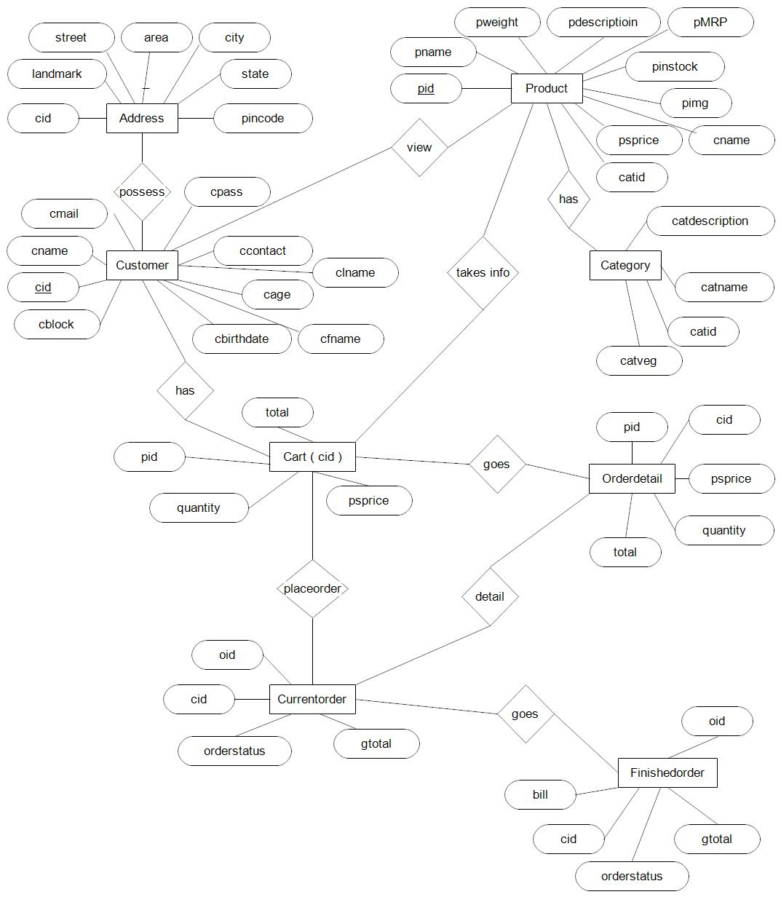

**Data Flow Diagram**

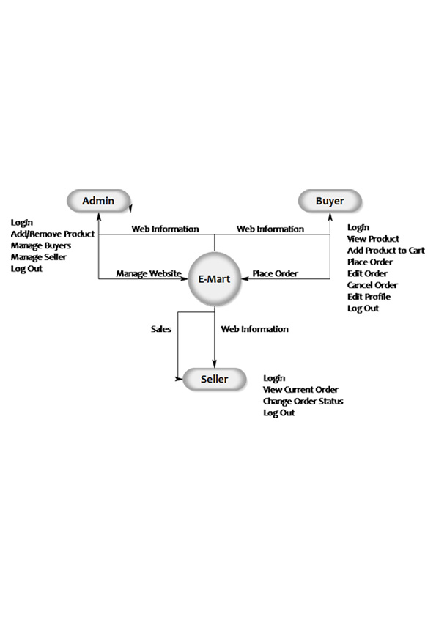

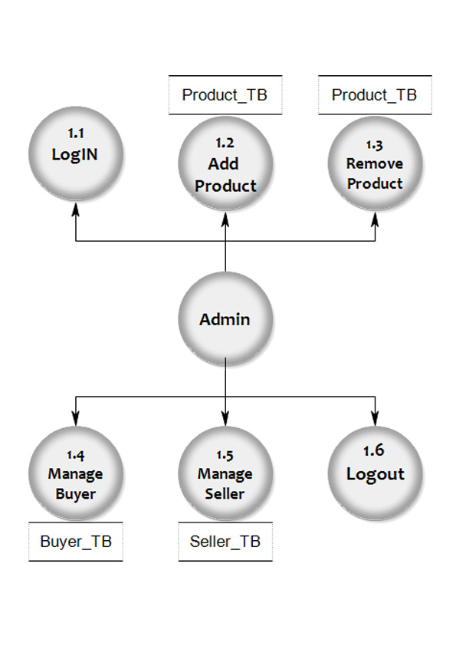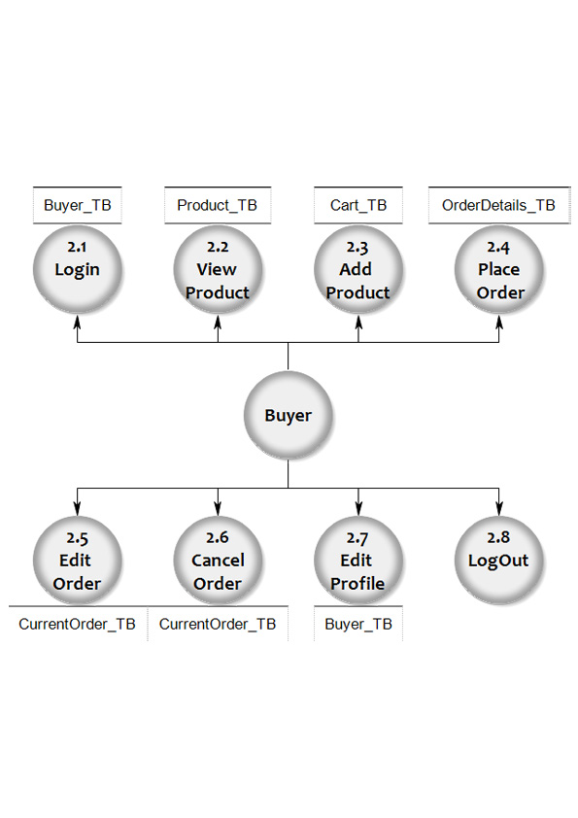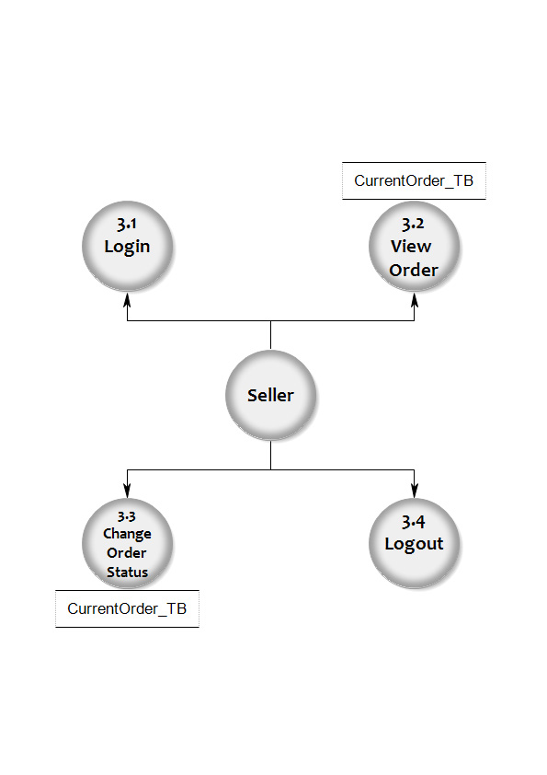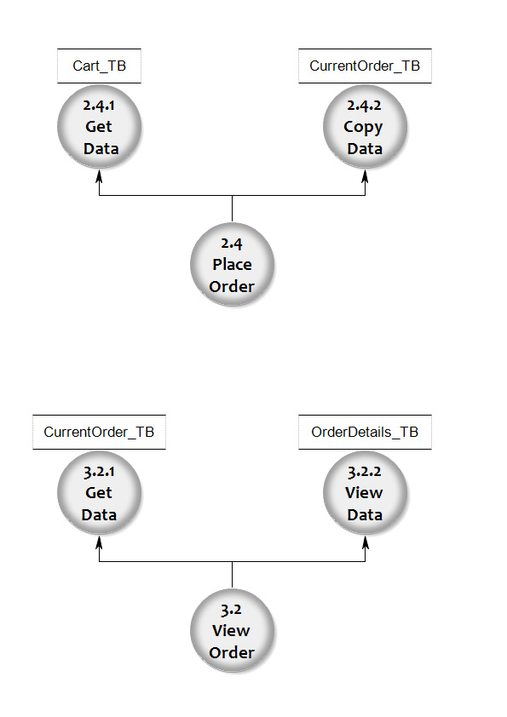­­­­

**Data Dictionary**

**Customer**:-

|  |  |  |  |
| --- | --- | --- | --- |
| Column Name | Data Type | Size | Constraint |
| Cid | Int | Auto Inc. | Primary key |
| Fname | Varchar | 25 |  |
| Lname | Varchar | 25 |  |
| Cname | Varchar | 25 | Unique |
| Cmail | Varchar | 50 | Unique |
| Cpass | Varchar | 15 |  |
| Contact | Int | 10 |  |
| Contact2 | Int | 10 |  |
| Gender | Boolean |  |  |
| Cimg | Varchar | 255 |  |
| Birthdate | Date |  |  |
| Blocked | Boolean |  |  |

**Address:-**

|  |  |  |  |
| --- | --- | --- | --- |
| Column Name | Data Type | Size | Constraint |
| cid | Int | Auto Inc. | Foreign key |
| Add1 | Varchar | 100 |  |
| Add2 | Varchar | 100 |  |
| Landmark | Varchar | 50 |  |
| Area | Varchar | 25 |  |
| City | Varchar | 25 |  |
| State | Varchar | 25 |  |
| Pin code | Int |  |  |

**Cart:-**

|  |  |  |  |
| --- | --- | --- | --- |
| Column Name | Data Type | Size | Constraint |
| Pid | Int | Auto Inc. | Foreign key |
| Quantity | Int | 10 |  |
| Sprice | Int | 10 |  |
| Total | Int | 10 |  |

**Category:-**

|  |  |  |  |
| --- | --- | --- | --- |
| Column Name | Data Type | Size | Constraint |
| catid | Varchar | 15 | Primary key |
| Catname | Varchar | 25 |  |
| Catdesc | Varchar | 500 |  |
| veg | Boolean |  |  |

**Current Order:-**

|  |  |  |  |
| --- | --- | --- | --- |
| Column Name | Data Type | Size | Constraint |
| Oid | Int | 10 |  |
| cid | Int | 10 |  |
| Gtotal | Int | 11 |  |
| status | Int | 2 |  |

**Finished Order:-**

|  |  |  |  |
| --- | --- | --- | --- |
| Column Name | Data Type | Size | Constraint |
| Oid | Int | 10 |  |
| cid | Int | 10 |  |
| Gtotal | Int | 11 |  |
| status | Int | 2 |  |
| Bill | Varbinary | 500 |  |

**Order Details:-**

|  |  |  |  |
| --- | --- | --- | --- |
| Column Name | Data Type | Size | Constraint |
| Oid | Int | 11 | Foreign key |
| pid | Int | 10 | Foreign key |
| Quantity | Int | 10 |  |
| Sprice | Int | 10 |  |
| Total | Int | 10 |  |

**Product:-**

|  |  |  |  |
| --- | --- | --- | --- |
| Column Name | Data Type | Size | Constraint |
| Pid | Int | Auto Inc. | Primary key |
| Catid | Varchar | 15 |  |
| Pname | Varchar | 50 |  |
| Weight | Int | 10 |  |
| Mrp | Int | 10 |  |
| Sprice | Int | 10 |  |
| Instock | Int | 10 |  |
| Pdesc | Varchar | 500 |  |
| Pimg | Varchar | 1000 |  |
| Visible | Boolean |  |  |

**Screen Shots**

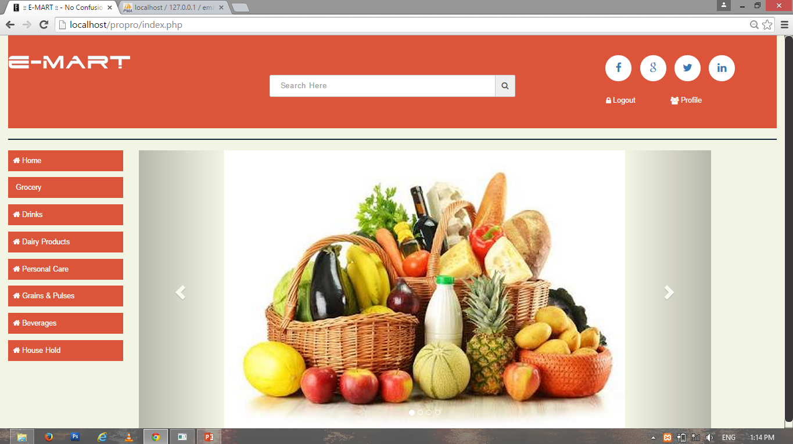

**Home**

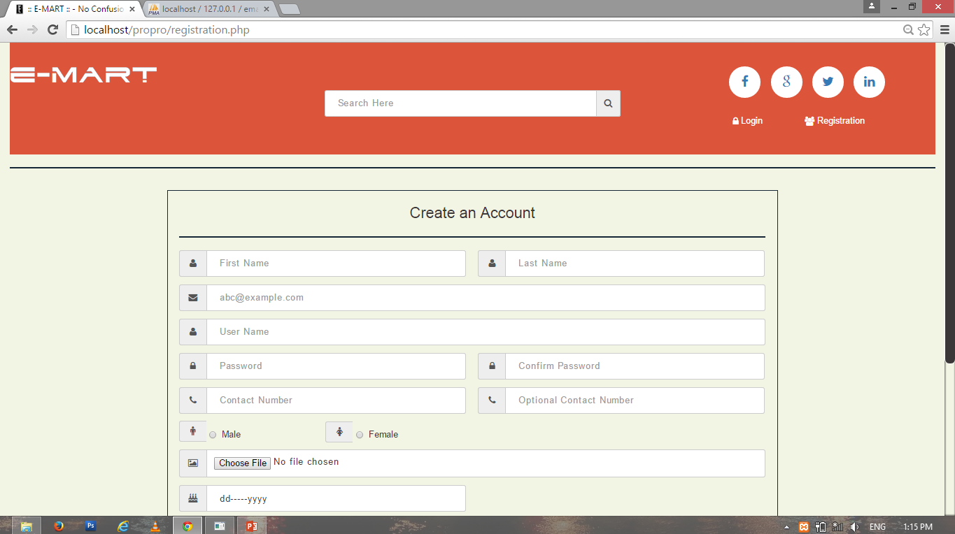

**Register**

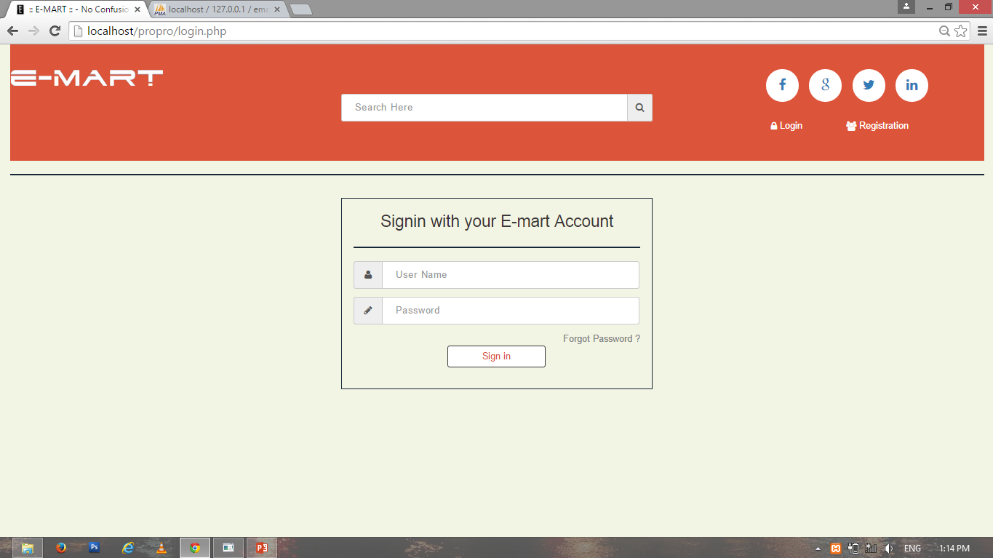

**Login**

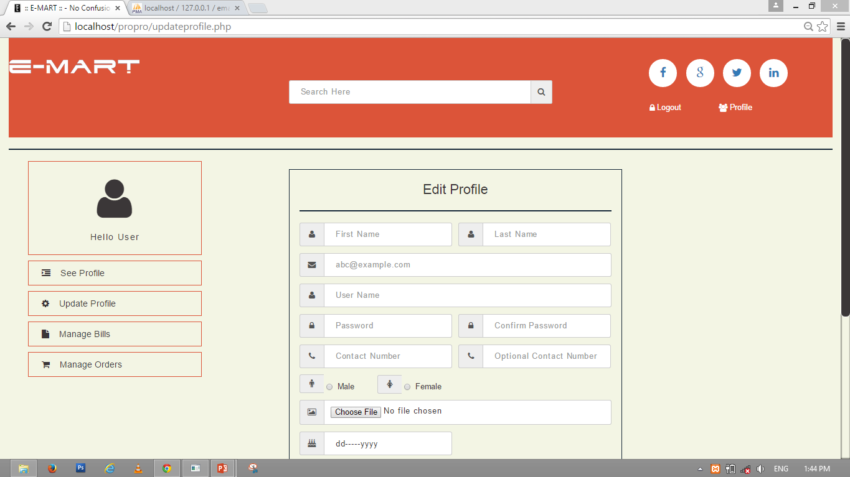

**Edit Profile**

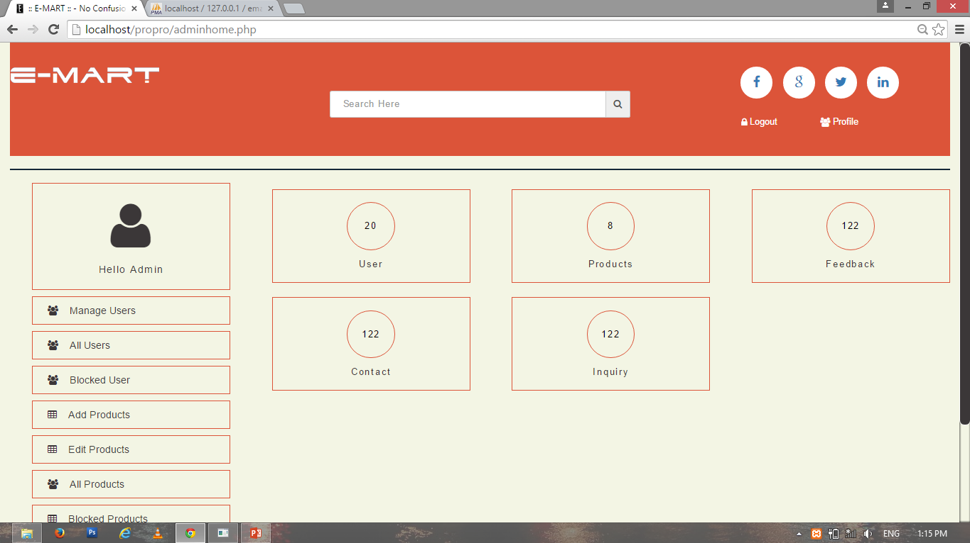

**Admin Home**

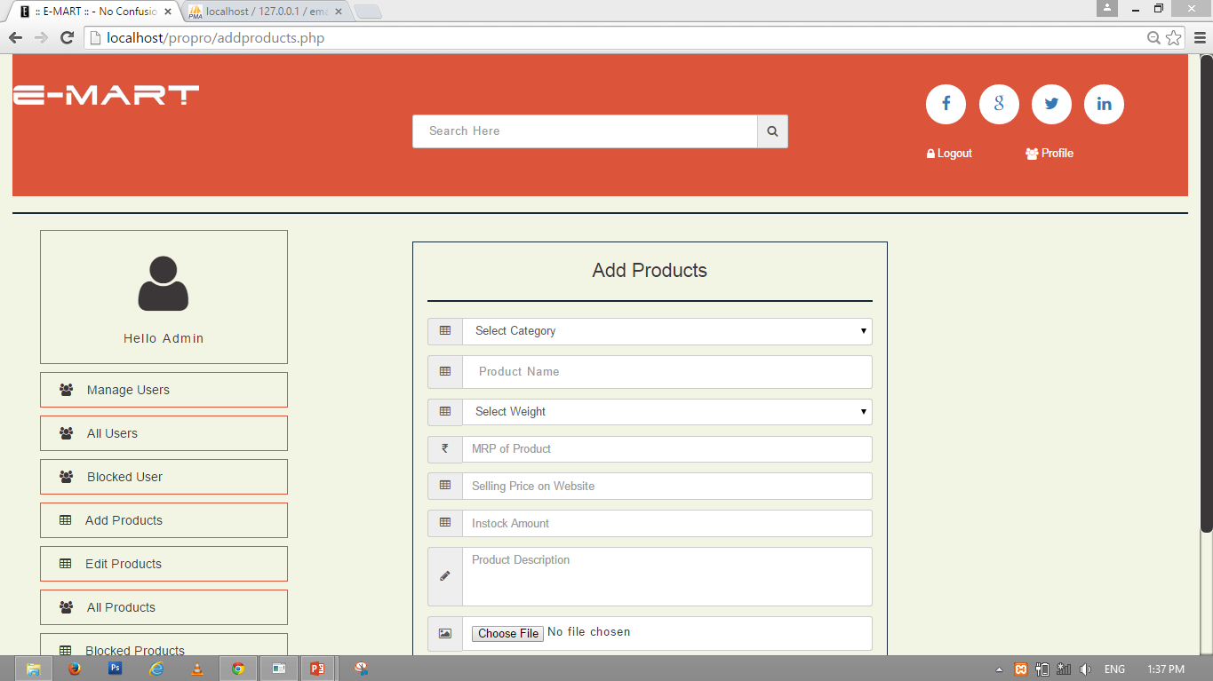

**Add Products**

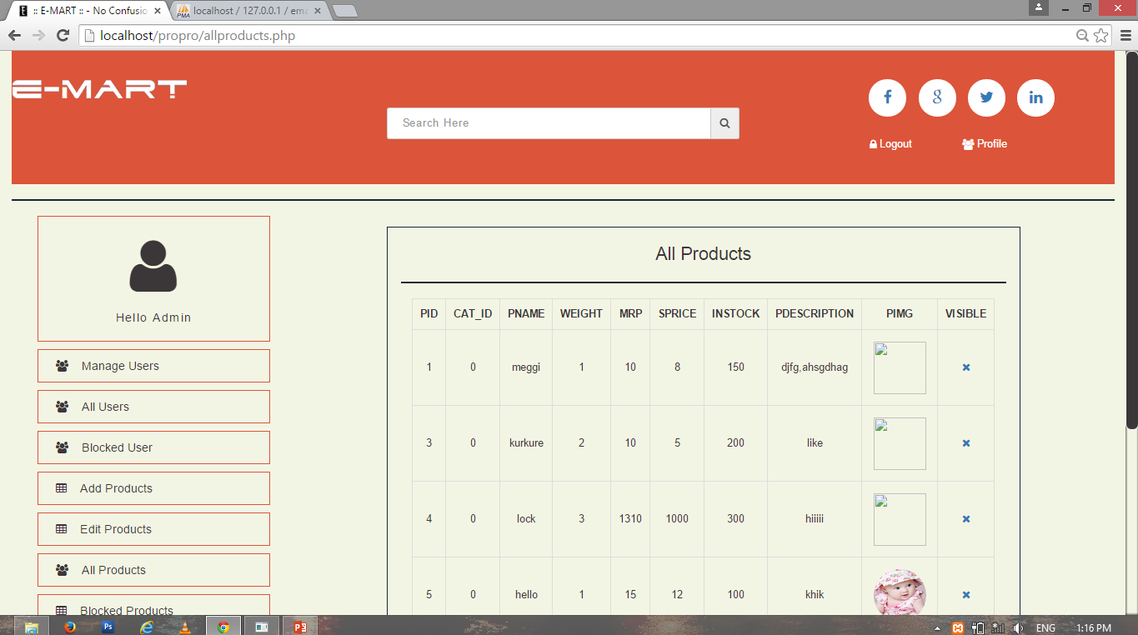

**All Products**

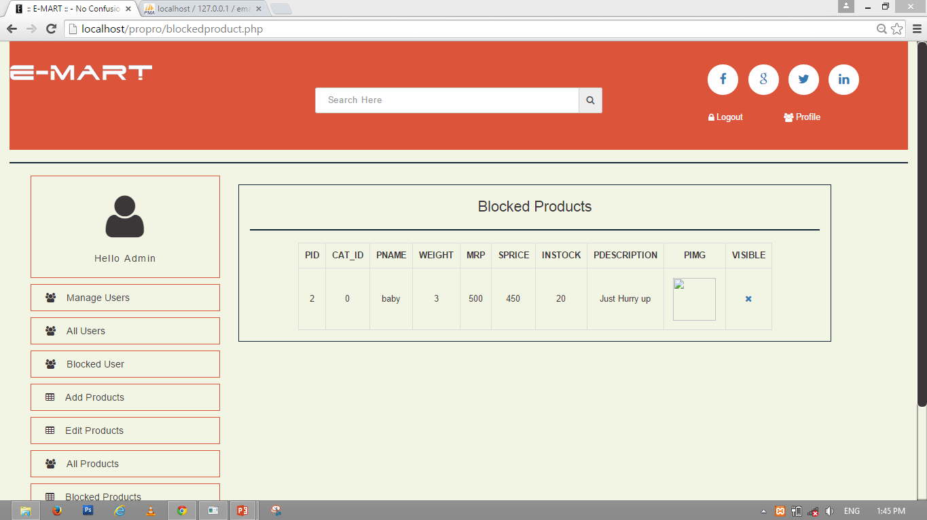

**Blocked Products**

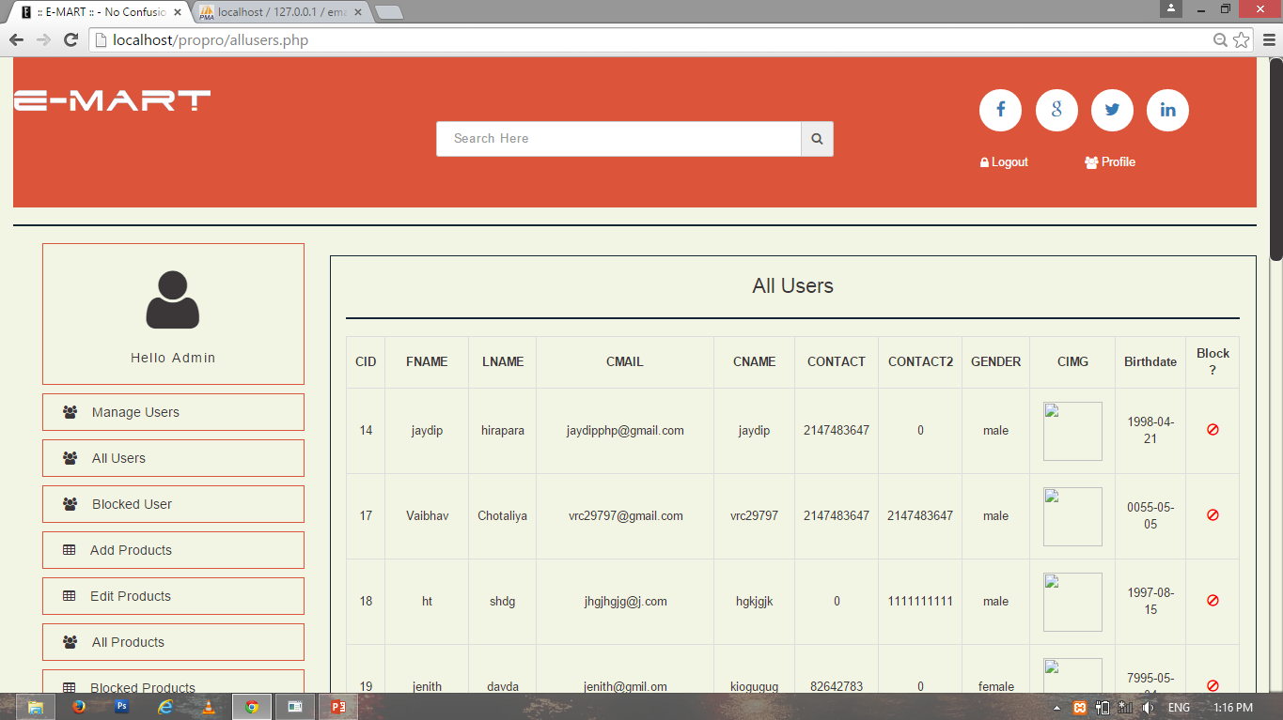

**All Users**

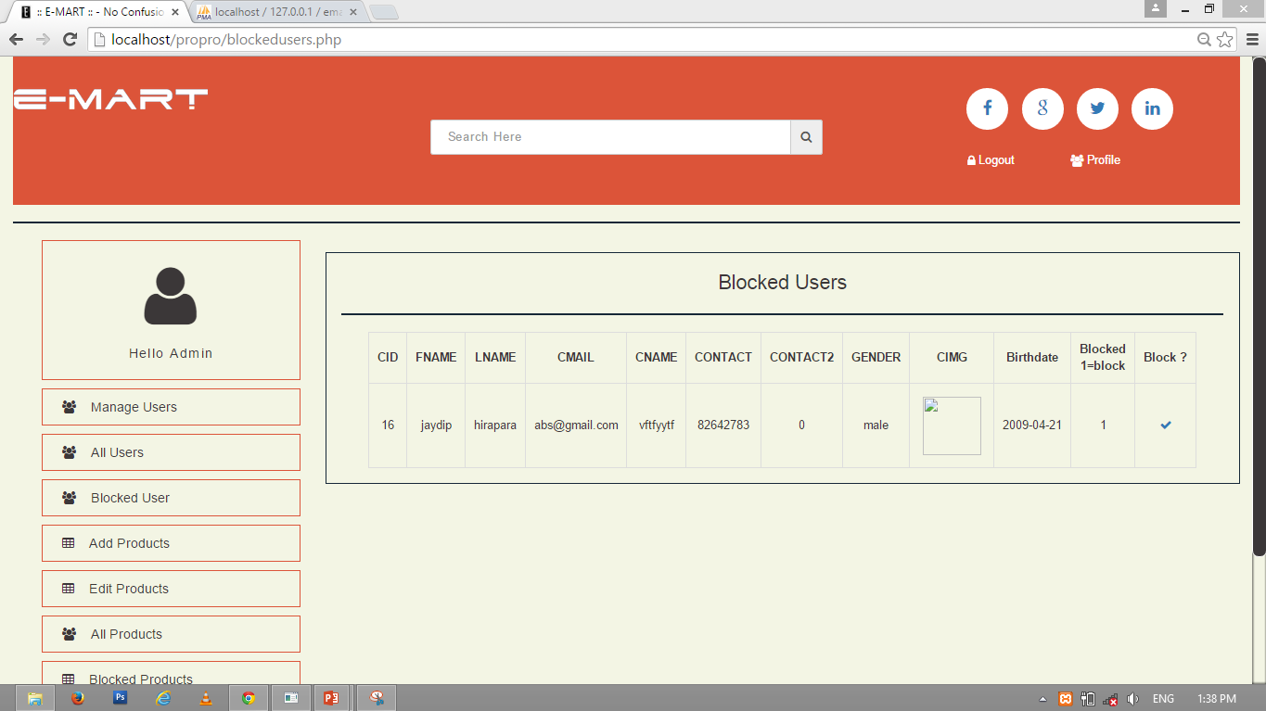

**Blocked Users**

**Advantages**

* E-mart offers several advantages to consumer and companies including improvements of productivity, customer satisfaction and general overall productivity.
* E-mart provides a wider scope of consumer that can be attained by the entrepreneur.
* This will create an easier way for customer to buy items that the business is offering and also can view reviews of the product and customer service.
* Customer would now be able to view and get update on their favourite brands or products and special discount that apply and would be able to make purchase any time.
* Customer will have direct access to the product information, company, promotion and much more.

**Limitation**

* Geographical limitations.
* Product information must be update at arbitrary interval.
* Payment methods are limited.

**Future Scope**

* Widen the range of product sold.
* Provide more payment methods.
* Widen the geographical area.

**Bibliography**

**Books:-**

* PHP with MY SQL
* PHP 5
* Dynamic Web Programming using PHP

**Bibliography:-**

* [www.w3schools.com](http://www.w3schools.com)
* [www.tutorialspoint.com](http://www.tutorialspoint.com)
* [www.getbootstrap.com](http://www.getbootstrap.com)